**GREEN MARK NATURAL SOLUTIONS**

**Project Report**

**Submitted by:**

**THASNEEM KP**

**TO**



**SOFTWARE TESTING**

**Luminar Techno Lab**

**Calicut**

**February 2024**

**ABSTRACT**

The purpose of the project is to test an E-commerce site **GREEN MARK NATURAL SOLUTIONS** (for purchasing ayurvedic herbal products and medicines) to check the presence of bugs and check the functionality of the software. Site is been tested both manual and automation with the help of selenium software. Manual is done in **MS Excel** and Automation is done using **Maven.**

Manual includes Test Scenarios, Test Case for each division, they are Sign Up, Home Page, Search and Cart and Bug Report which include all the information about the Bug.

Automation includes Navigation, Sleep, Scroll Down, Window Handle, Drop Down, Actions etc.

**CONTENT**

1: Introduction

2: Test Environment

3: Manual Testing

3.1-Test Scenario

3.2-Testcase

3.2-Bug Report

4: Automation Testing

4.1-Recording

4.2-CSV Report

4.3-Emailable Report

4.4-Extend Report

5: Screenshot

6: Conclusion

7: Reference

**1.INTRODUCTION**

We are testing the website **GREEN MARK NATURAL SOLUTIONS** Manually using testcases and automatically with the help of automated testing tool Selenium in java. Software testing is carried out in a systematic manner with the intent of finding defects in a system. It is required for evaluating the System.

There are many reasons why software testing has gained so much of importance in the field of information technology. Firstly, testing helps in reducing the overall cost of the software development project. If testing is ignored in the initial development stages to save a small amount of money, then it may turn out to be a very expensive matter later because as you move on with development process it becomes more and more difficult to trace back defects and rectifying one defect somewhere can introduce another defect in some other module.

**2.TEST ENVIRONMENT**

*System: Dell

*Windows Version: Windows 11 Home

*Manual testing: Excel 2019

*Automation Testing: Eclipse

*Testing Tool: Selenium 4.18.2

*Language: Java

*Framework: Maven

**3.MANUAL TESTING**

**Manual Testing** is a type of software testing in which test cases are executed manually by a tester without using any automated tools. The purpose of Manual Testing is to identify the bugs, issues, and defects in the software application. Manual software testing is the most primitive technique of all testing types and it helps to find critical bugs in the software application

**3.1 TEST SCENARIO**

[**TestScenario_GreenMark.docx**](https://1drv.ms/w/s!Av0akJ90vfYEgidoWhEuAAldtX0E?e=gSDLJs)

**3.2 TEST CASE**

[**TestCase_GreenMark.xlsx**](https://1drv.ms/x/s!Av0akJ90vfYEgmz8yyT2BlJFKzUc?e=fpwNcn)

**3.3 BUG REPORT**

[**TestCase_GreenMark.xlsx**](https://1drv.ms/x/s!Av0akJ90vfYEgmz8yyT2BlJFKzUc?e=fpwNcn)

**4. Automation**

Automation Testing is the process of using tools, scripts, and software to perform test cases by repeating pre-defined actions. Test Automation focuses on replacing manual human activity with systems or devices. Because automated testing is done through an [automation tool](https://www.edureka.co/blog/software-testing-tools/), it consumes less time in exploratory tests and more time in maintaining test scripts while increasing overall test coverage.

The automation testing software can also enter test data into the System Under Test, compare expected and actual results and generate detailed test reports. Software Test Automation demands considerable investments of money and resources.

Tests which are used:

1. Unit Test

**Unit Testing** is a type of software testing where individual units or components of a software are tested. The purpose is to validate that each unit of the software code performs as expected. Unit Tests isolate a section of code and verify its correctness. A unit may be an individual function, method, procedure, module, or object.

1. System Test

**System Testing** is a level of testing that validates the complete and fully integrated software product. The purpose of a system test is to evaluate the end-to-end system specifications. System Testing is defined as a series of different tests whose sole purpose is to exercise the full computer-based system.

1. User Acceptance Test

**User Acceptance Testing (UAT)** is a type of testing performed by the end user or the client to verify/accept the software system before moving the software application to the production environment. UAT is done in the final phase of testing after functional, integration and system testing are done.

1. Smoke Test (Functional Test)

**Smoke Testing** is a software testing process that determines whether the deployed software build is stable or not. Smoke testing is a confirmation for QA team to proceed with further software testing. It consists of a minimal set of tests run on each build to test software functionalities. Smoke testing is also known as “Build Verification Testing” or “Confidence Testing.”

**4.1 RECORDING**



**"C:\Users\dell\Videos\Screen Recordings\Screen Recording 2024-07-26 010411.mp4"**

**4.2 CSV REPORT**

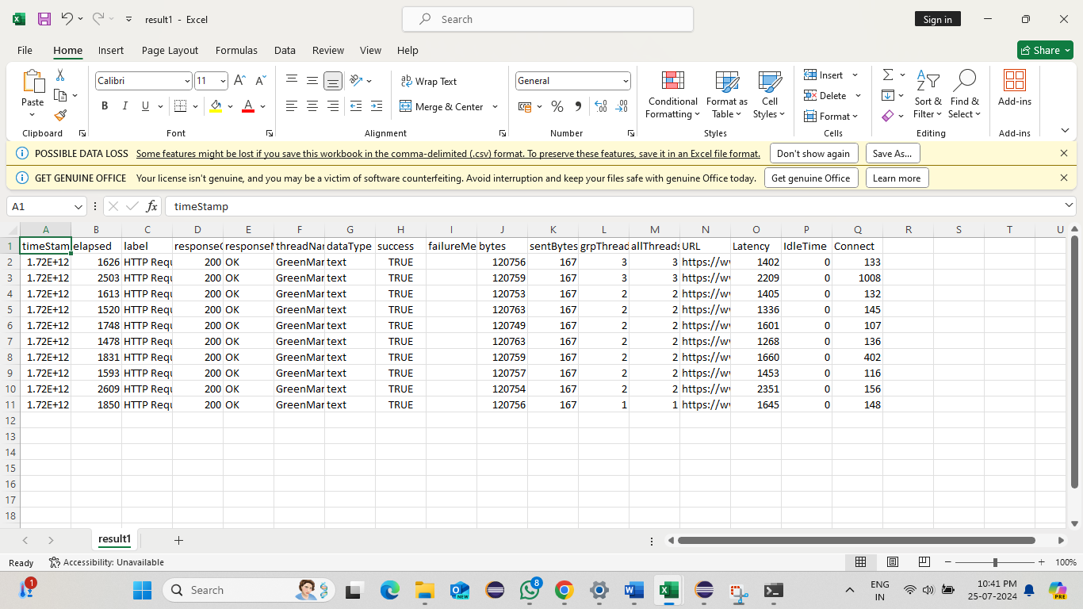

**4.3 EMAILABLE REPORT**



**"C:\Users\dell\Videos\Screen Recordings\Screen Recording 2024-07-25 224342.mp4"**

**4.4 EXTEND REPORT**

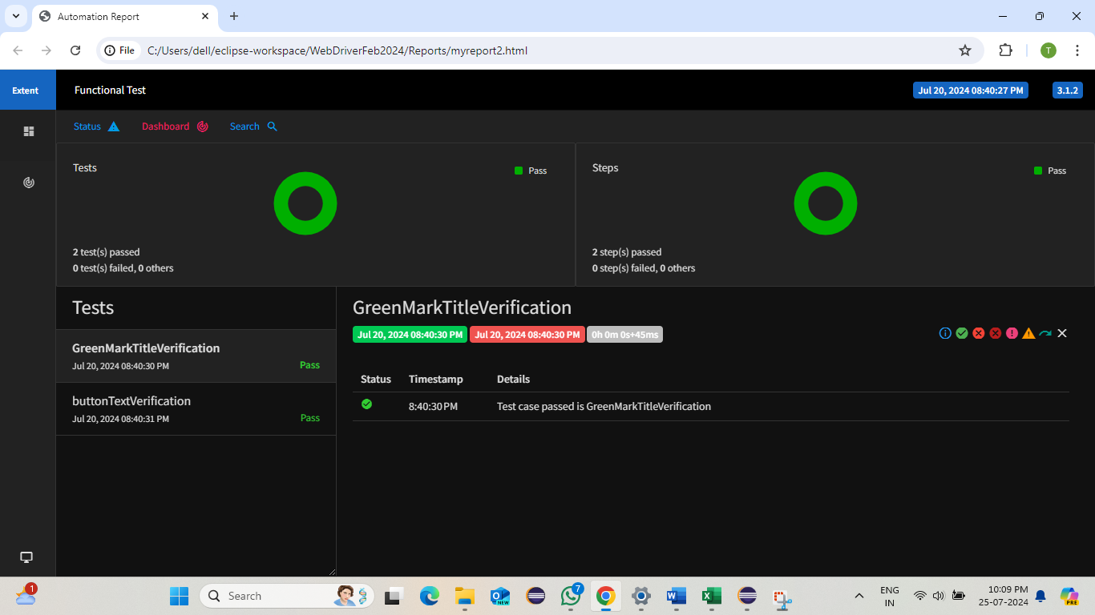

**5.SCREENSHOT**

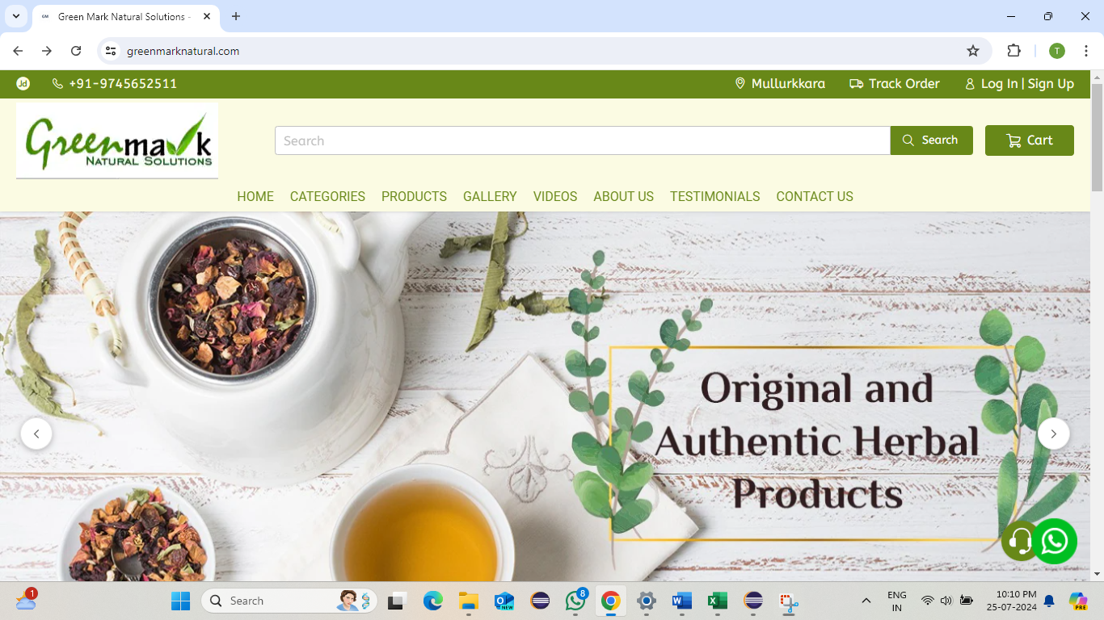

**6.CONCLUSION**

Automation testing is more efficient and reliable than manual testing: Automation testing allows for faster and more accurate testing of the GREEN MARK NATURAL SOLUTIONS site. With automation testing, test scripts can be written to cover a wide range of scenarios and execute them quickly, reducing the time and effort required for testing.

Manual testing is still necessary: Despite the advantages of automation testing, manual testing is still necessary to validate certain scenarios that may be difficult to automate, such as user interface testing and exploratory testing. Manual testing also provides a human perspective that may be difficult to replicate with automation testing.

The GREEN MARK NATURAL SOLUTIONS site has good functionality and usability: Both manual and automation testing revealed that the GREEN MARK NATURAL SOLUTIONS site has good functionality and usability. The site performed well in terms of responsiveness, navigation, and overall user experience.

Some minor issues were identified are: During automation testing some of the locators could not inspect and therefore some actions could not be done properly. These issues did not significantly impact the functionality or usability of the site but could be improved upon to enhance the user experience.

In conclusion, the GREEN MARK NATURAL SOLUTIONS site performed well in both manual and automation testing, with only minor issues identified. The combination of manual and automation testing provided a comprehensive evaluation of the site's functionality and usability, and both types of testing were valuable in ensuring a high-quality user experience.

In the future versions, site can be more welcoming and user-friendly, which helps in the interaction easier and also adding new varieties of items and different methods to buy them.

**7.REFERENCES**

1. <https://www.edureka.co/>
2. <https://www.javatpoint.com/software-testing-tutorial>
3. https://www.guru99.com/
4. <https://www.geeksforgeeks.org/software-testing-basics/>
5. http://www.youtube.com